26.77: a) When the bridge is balanced, no current flows through the galvanometer:
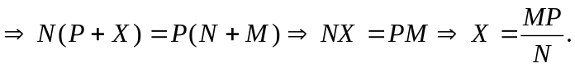
(b) 